Luisa Chiu

11/10/2023

Homework 3: Scale-Invariant Feature Detection

**Qualitative Evaluation Questions:**

1. *What is the effect of changing the thresh parameter?  Show and analyze example results where thresh is increased and decreased from the default.*

As stated in the code documentation, changing the thresh parameters changes the “minimum absolute response value for feature detection”. Increasing thresh decreases the number of features detected, so there are less circles drawn. Decreasing thresh increases the number of features detected, so there are a lot of circles drawn compared to the default image.

Default thresh: 0.05

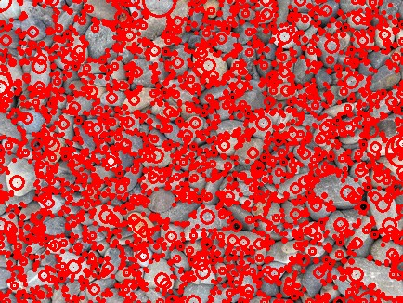

Increasing thresh: 0.08

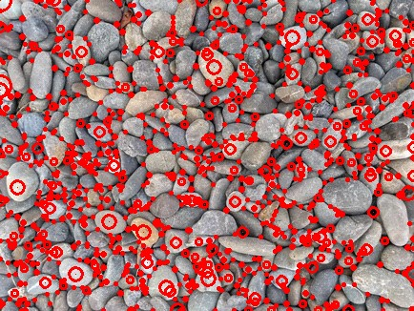

Decreasing thresh: 0.01

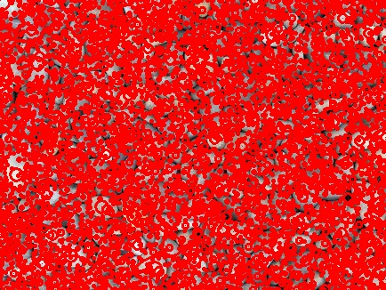

1. *What is the effect of increasing the sigma parameter?  Show and analyze example results where sigma is increased from the default.*

Generally, increasing sigma when using a Gaussian filter blurs the image more. Therefore, the find_features function will not pick up features on a blurry image as easily as it would on a sharper image. When we increase sigma, we see that there are not as many circles drawn on the image, and most of the circles are relatively the same size. When we decrease sigma, we see the circles drawn around the outline of the rocks.

Default sigma: 1

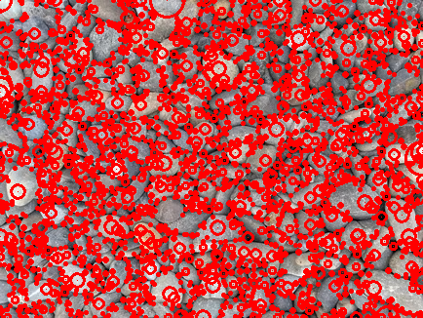

Increasing sigma: 3

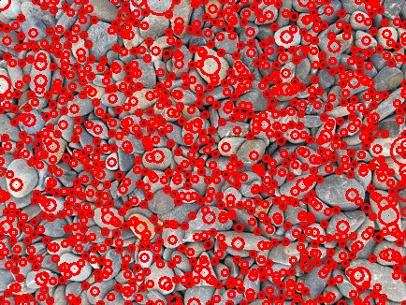

Decreasing sigma: 0.02

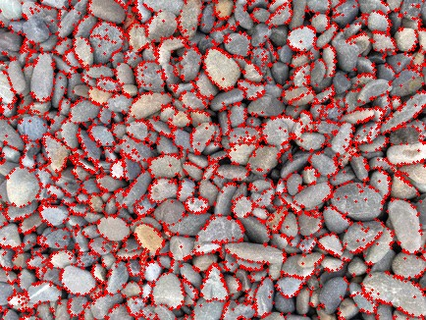

1. *Using an image of your choice (from the internet or captured by you on your phone), first hypothesize where you think features will be found, and then compare to what the detector actually finds.*

I chose an image of my cousin’s cat:



I believe the features will be found around the edges of the chair or any parts that have contrasting light to dark features, such as the whiskers. This is the outcome:

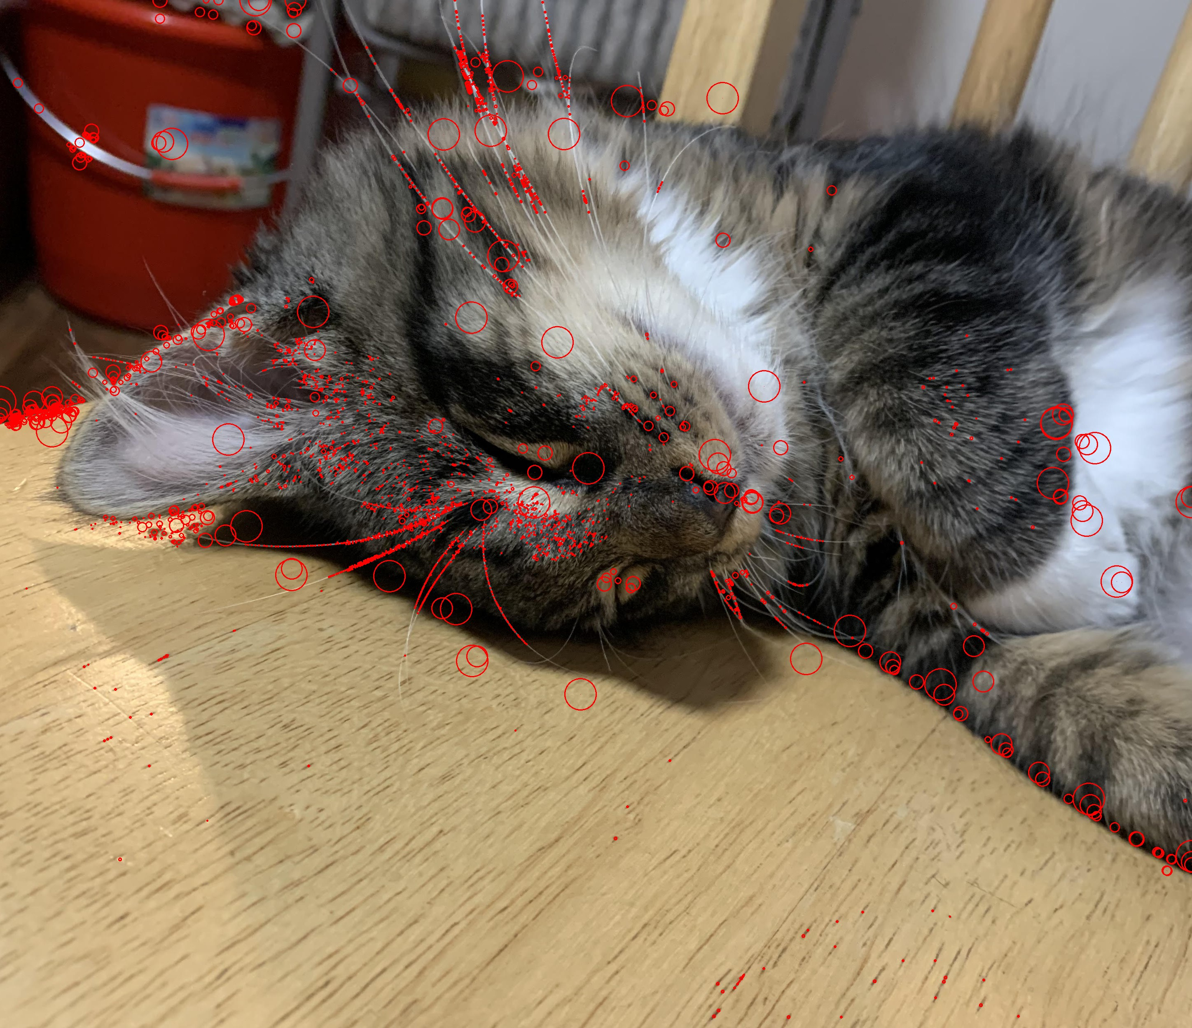

I noticed that the edge of the chair on the left side was detected, but the wooden bars of the chair behind the cat were not detected. This may be because the wooden bars were more shaded around its edges, whereas the chair seat was hit with more light and contrasted more against the darker wooden floor. The cat’s whiskers and outline against the chair were detected, and some of the dark grain patterns in the chair seat were also detected.

**Solution Summary:**

For this homework, I created three functions: get_dog_response_stack(), find_features(), and draw_fatures(). Firstly, for get_dog_response_stack(), I converted the input image to grayscale, and then normalized the values from 0 to 1 by dividing by 255. For this function, I developed code to loop through two different layers going through a gaussian filter and finding the difference between them, then appending that and stacking it to create an array of shape (self.nblur, height, width). To do so, I calculated the first sigma value using the equation self.sigma*(1.5^0), and then used a for loop to loop through layers 0 to 9. Inside the for loop, I re-defined a sigma value with self.sigma*(1.5^(i+1)) so I could calculate sigma for the next Gaussian filter. Then, I appended the difference between the layers passed through the gaussian filter. After the for loop, I used np.stack() to stack all of the difference of Gaussians and returned it. For find features, I used minimum_filter() and maximum_filter() to compute local minimum and local maximum of the image using a 3D filter size of (3, 3, 3). Next, I used np.argwhere to find where the responses were equal to the local minimum and maximum, and where the absolute values of the responses/input image were greater than the threshold value self.thresh. I then created a list of tuples, (level, y, x), and returned this list. In draw_features(), I used a for loop to draw the detected features on the image in the form of a dot and circle. The cv2.circle() functions were used to do so, and the radius of the circles drawn were equal to the sigma value at that level. Lastly, I ran these functions in process.py to produce my output image ‘features.png’.